2.2 Religious Groups in Palestine

Religious Group | Facts
Sanhedrin  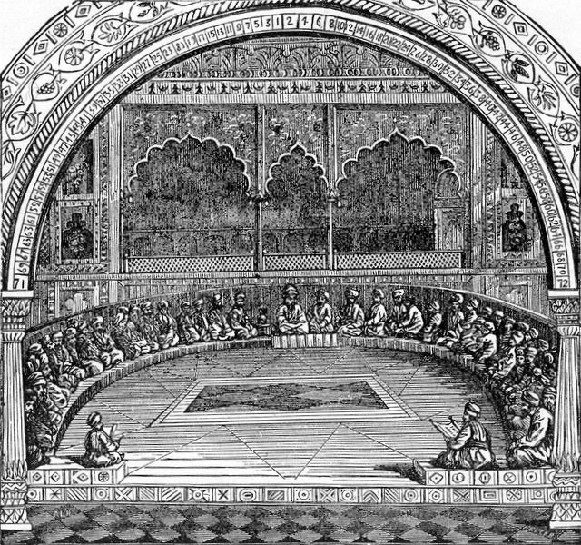 | -the Jewish “_________________________”  -an assembly of _______ judges, each major city in ancient Israel would have its own Sanhedrin  -made up of Pharisees and Sadducees  -Dealt only with __________________  -they could not sentence anyone to death for violating Jewish religious customs - needed Roman approval (e.g. Jesus being brought before Pilate)
Scribes  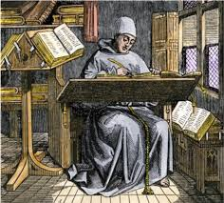 | -person who writes ______________ or _______________ by hand as a profession  -Scribes lost most of their importance and status with the advent of ________________  -They were professional lawyers and teachers of the OT law  -Most were _____________ - devoted to the studying of God’s laws  -Pharisees were the highest percentage of scribes

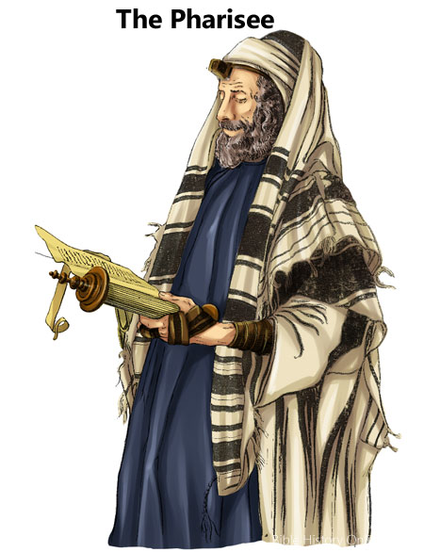 | -Pharisees get their name from the Hebrew verb ___________, which means “______________________”  -They originated after the Maccabean revolt - strongly opposed to ___________________  -About 6,000 strong during the reign of Herod the Great  -Largest Jewish religious party, mostly _______________________  -They were very intense and legalistic about keeping___________________________________________________________________  especially on the Sabbath (which is why Jesus drove them crazy!)
Sadducees  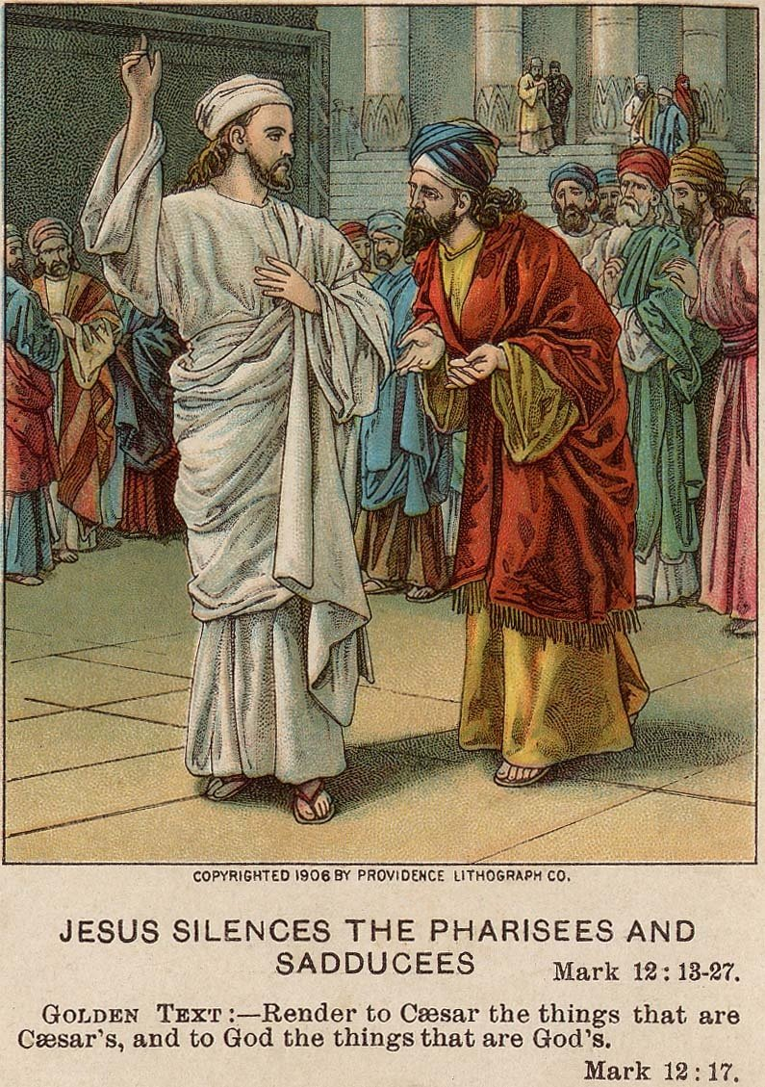 | -A smaller group than the Pharisees but were influential because of their status as the leaders of the priestly class  -Did not believe in the ___________________ (e.g. resurrection of the dead, miracles, angels, spirits, etc.)  -Were mostly wealthy business leaders who had friendly relations with the Roman government - Pharisees accused them of being “_____________” because of this  -They controlled the ____________________ - made sure the High Priest of the synagogue was also a Sadducee - this person would be the “go-to” guy with the Roman government

