2.1 The Politics and Geography of Palestine

The region of Palestine, while quite small, was a critical trade route in the ancient world | 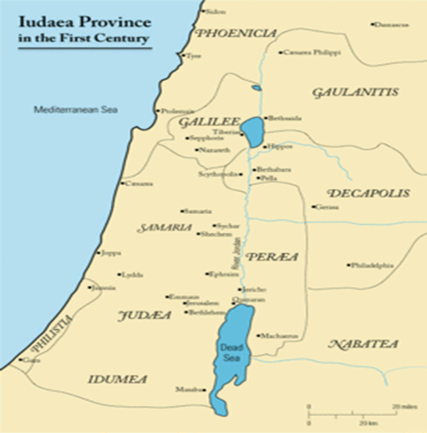
Palestine had _______ distinct regions - Galilee to the north, Samaria to the south, and Judea, even further south.

Regions | Facts
Galilee
Samaria
Judea

