1.8 The Break up of the Greek Empire
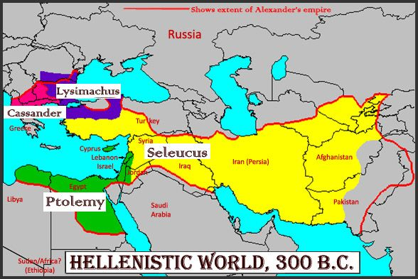

- Following the death of Alexander, his empire was divided into _________ parts
- The Hebrew/Jewish people came under the rule of the ____________ (part of the Egyptian royal family) for a while
- Most of the Israelites were under the rule of the ______________, a vicious people rule by a man named ____________________________ (he hated anything and everything Jewish)
- Antiochus pushed ________________ to the extreme, wanting all his subjects to ___________ Greek gods, __________ Greek, and _____________ Greek customs
- Antiochus went so far as to construct an altar to the mythical Greek god, ___________, in the Jewish temple and demanded they worship it!
- Jews that strongly opposed Antiochus and his persecution were called ___________ Jews.
- Persecution continued until 168 BC, when ______________ refused to offer sacrifices to the altar of Zeus. When Antiochus heard about this, he sent a representative to investigate and Mattathias killed him. He then __________ with his sons into the wilderness.
- Mattathias died shortly after, but his son __________________ carried on the revolt.
- Joined by the _______________________ living in the area, the Jewish people captured Jerusalem in 165 BC.
- In December that year, they refurbished the temple, purified it of Greek filth, and rededicated it to God - an event commemorated by the Jews still today in the ______________________ or __________________.

