1.4 The Greek Empire (331-166 B.C)
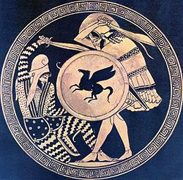
The Persian Empire continued to conquer new territory and eventually invaded “Greece” and fought in a series of wars referred to as the _______________________________

Separate Greek city states formed __________________ to defeat the Persians.

The Greeks, especially the ______________ (a fierce warrior Greek city-state) constantly challenged the rule of the Persian Empire.

Greek triumph ensured _____________________________________________________

Following the war against the Persians, the Greeks fell into a massive _________ _____ (Greeks fought against Greeks)

___________________________ emerged out of the conflict as a brave and strong leader, with a goal of _________________ all of the Greek city-states.

Greek unity was achieved but the vast empire was left without a leader until his son ___________________ took over.
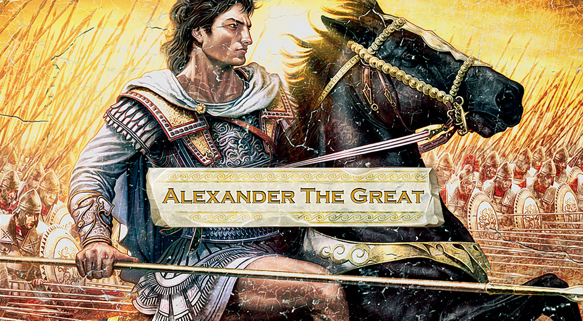
Alexander the Great would influence the western world for the next millennium, his ideas and Greek culture spread everywhere.

He insisted that people learn ____________ as their 2nd language.

Greek traditions and religion were ________________ throughout the area he controlled.

The Jewish people had a different reaction than most to Greek tradition and religion. They asked these types of questions:
Would they be able to maintain their _____________
What about their firm belief in one God?
What about religious/dietary observations?

