1.2 Intertestamental Period Introduction

The intertestamental period is the Protestant term term for the gap of time between the period covered by the Hebrew Bible and the period covered by the Christian New Testament. Traditionally, it is considered to cover roughly four hundred years, spanning the ministry of Malachi (c. 420 BC) to the appearance of John the Baptist in the early 1st century AD. It is known by members of the Protestant community as the "400 Silent Years" because it is believed to have been a span where God revealed nothing new to his people. An understanding of the events of the intertestamental period provides context for the New Testament.
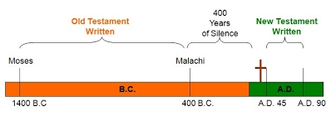
During the time from Malachi to Christ, the Israelites lived under six different empires:
1. 4.
2. 5.
3. 6.

Because the Empires ruled differently, the expectations of who or what exactly the Messiah would be often changed. The Israelites asked questions like:

1.3 The Persian Empire (536-331 B.C)

Israelites under the Babylonians | Fall of Babylon (539 B.C)
Cyrus the Great (R. 559-530 B.C) | Jerusalem Restored

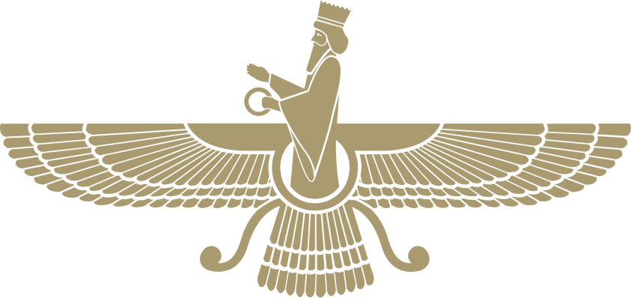

Which books in the O.T. talk about the Persian Empire?

